

**RAMANUJAN COLLEGE**

**(UNIVERSITY OF DELHI)**

**SUBJECT-DIGITAL IMAGE PROCESSING**

**(PRACTICAL FILE)**

**NAME=MOHD SHOHEL**

**COLLEGE ROLL NO. = 20201417**

**EXAMINATION ROLL NO. = 20020570022**

**SUBMITTED TO = MRS. BHAVYA AHUJA**

**SEMESTER = 5th**

Question 1 : Write program to read and display digital image using MATLAB or SCILAB

a. Become familiar with SCILAB/MATLAB Basic commands

b. Read and display image in SCILAB/MATLAB

c. Resize given image

d. Convert given color image into gray-scale image

e. Convert given color/gray-scale image into black & white image

f. Draw image profile

g. Separate color image in three R G & B planes

h. Create color image using R, G and B three separate planes

i. Flow control and LOOP in SCILAB

j. Write given 2-D data in image file

Solution :

Code -

% (a)

a=imread("C:\Users\MOHD SHOHEL\Downloads\lion.jpg");

imshow(a);

title("original image");

% (b)

a=imread("C:\Users\MOHD SHOHEL\Downloads\lion.jpg");

imshow(a);

title("original image");

% (c)

img = imread('C:\Users\MOHD SHOHEL\Downloads\fish.jpg');

img1 = imresize(img,2); // resized image

subplot(2,2,1), title('Original Image'), imshow(img);

xlabel(strcat(string(size(img)),' * '));

subplot(1,2,2), title('Resized Image'), imshow(img1);

xlabel(strcat(string(size(img1)),' * '));

% (d)

RGB=imread("C:\Users\MOHD SHOHEL\Downloads\flower.jpg");

figure

imshow(RGB);

title("Original image");

I=rgb2gray(RGB);

figure

imshow(I);

title("gray-scale image");

% (e)

im1 = imread('C:\Users\MOHD SHOHEL\Downloads\fish.jpg');

bw_img = im2bw(img1, 0.5);

subplot(1,2,1), title('Original Image'), imshow(img1);

subplot(1,2,2), title('B&W Image'), imshow(bw_img);

% (f)

i = imread("C:\Users\MOHD SHOHEL\Downloads\fish.jpg");

improfile(i);

% (g),(h)

i = imread("C:\Users\MOHD SHOHEL\Downloads\fish.jpg");

redChannel = i(:,:,1); // Red channel

greenChannel = i(:,:,2); // Green channel

blueChannel = i(:,:,3); // Blue channel

// Create an all black channel.

allBlack = zeros(size(i, 1), size(i, 2), 'uint8');

// Create color versions of the individual color channels.

just_red = cat(3, redChannel, allBlack, allBlack);

just_green = cat(3, allBlack, greenChannel, allBlack);

just_blue = cat(3, allBlack, allBlack, blueChannel);

// Recombine the individual color channels to create the original RGB image again.

recombinedRGBImage = cat(3, redChannel, greenChannel, blueChannel);

// Display them all.

figure

subplot(3, 3, 2);

imshow(i);

fontSize = 2;

title('Original RGB Image', 'FontSize', fontSize)

subplot(3, 3, 4);

imshow(just_red);

title('Red Channel in Red', 'FontSize', fontSize)

subplot(3, 3, 5);

imshow(just_green)

title('Green Channel in Green', 'FontSize', fontSize)

subplot(3, 3, 6);

imshow(just_blue);

title('Blue Channel in Blue', 'FontSize', fontSize)

subplot(3, 3, 8);

imshow(recombinedRGBImage);

title('Recombined to Form Original RGB Image Again', 'FontSize', fontSize)

% (i)

for i=1:10

if modulo(i,2) == 1 then

disp(i);

else

continue;

end,

end;

% (j)

mat = zeros(20,20,'uint8');

mat(5:10, 5:10) = 1; // box

mat(2, 3:15) = 1; //vertical line

mat(2:18, 3) = 1; //horizontal line

mat(1:4:20,1:4:20) = 1; // linear points

disp('Given 2D data : ', mat);

title('Created Image from matrix'), imshow(mat2gray(mat));

Output :

(a)

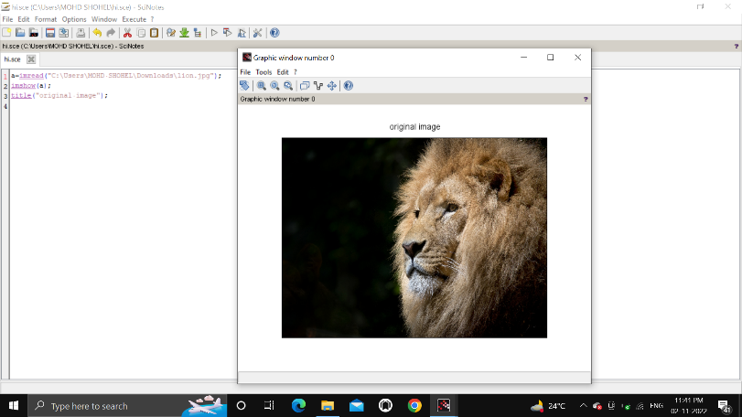

(b)



(c)

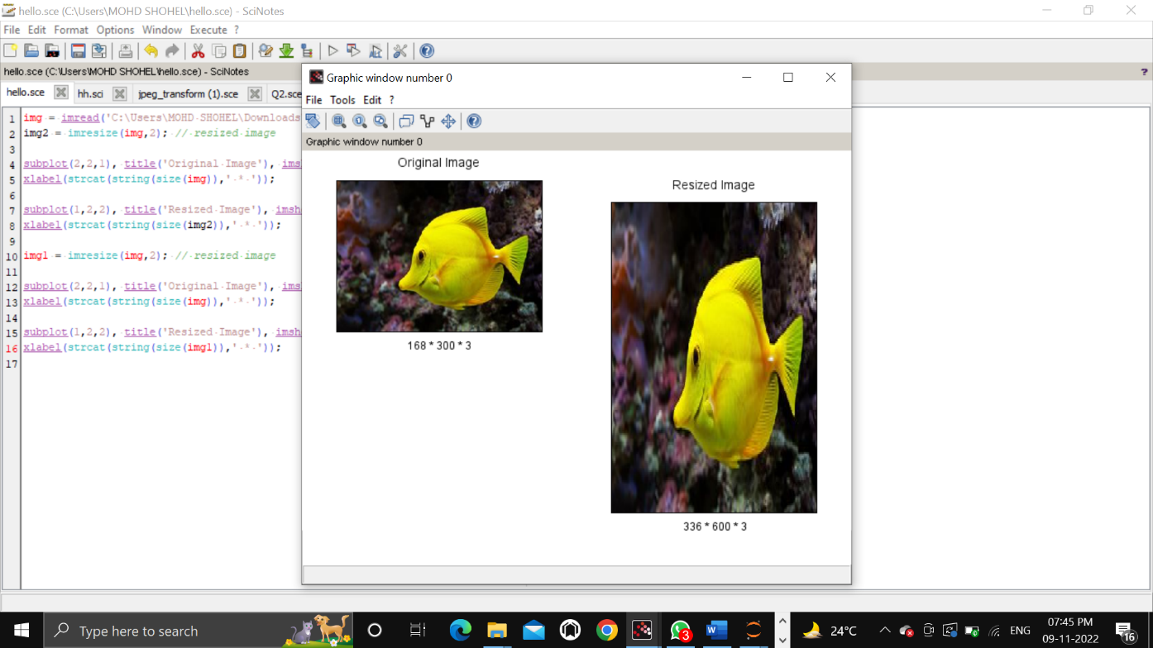

(d)

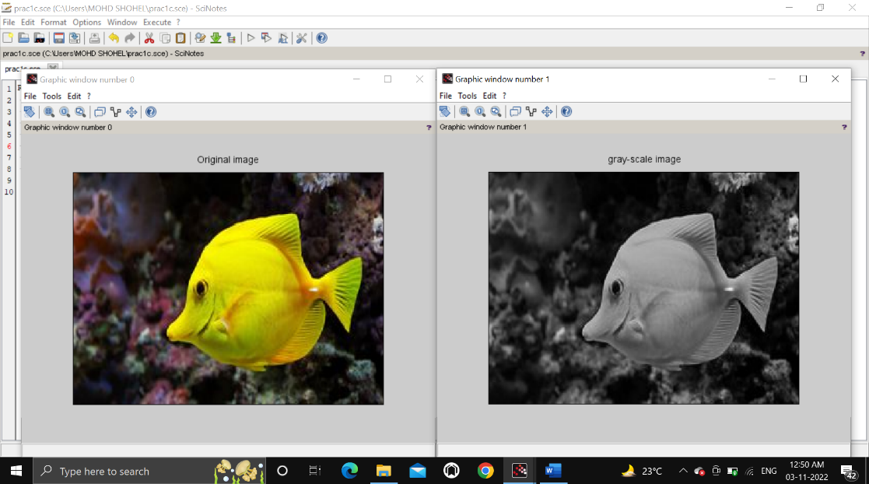

(e)

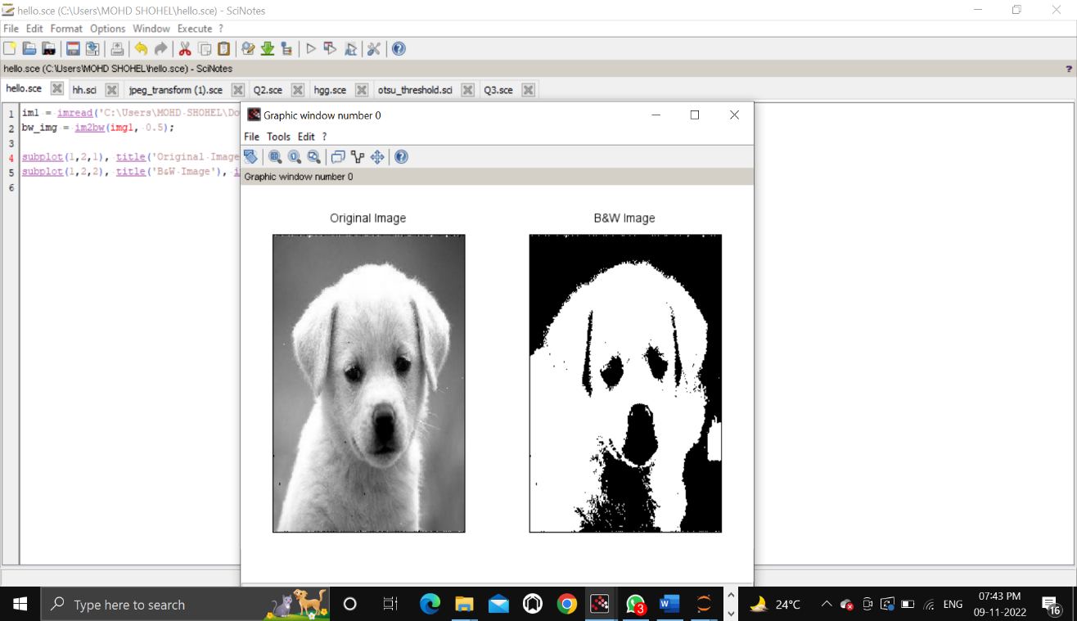

(f)

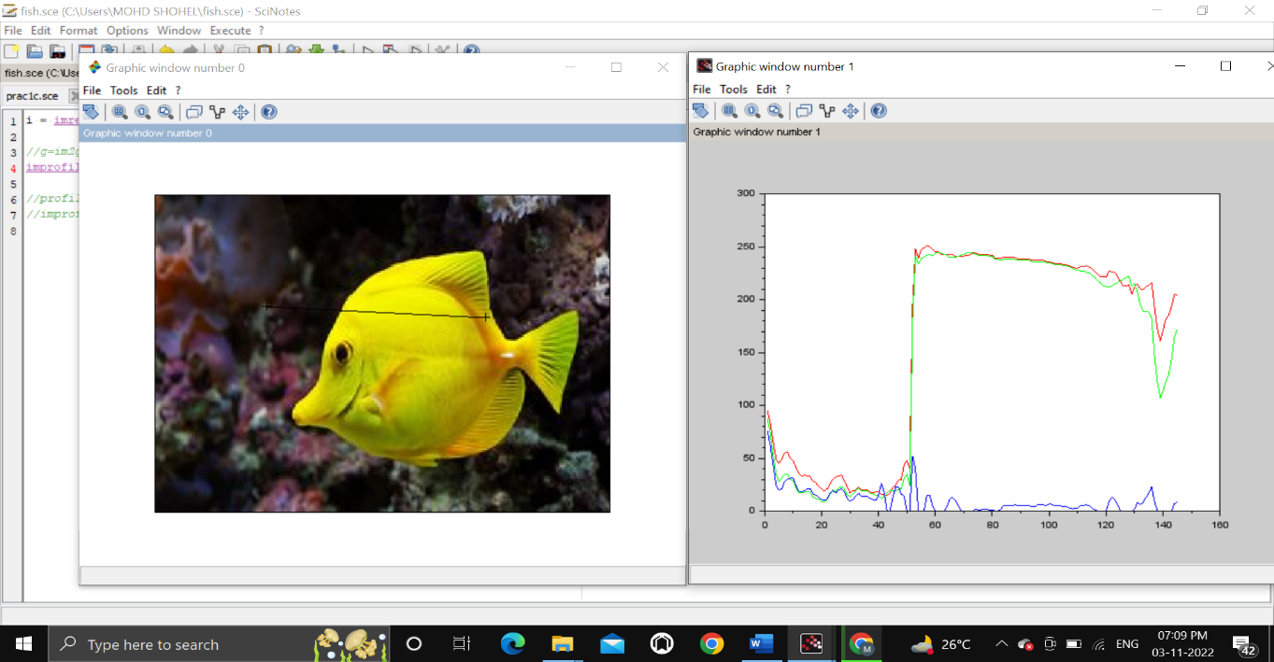

(g),(h)

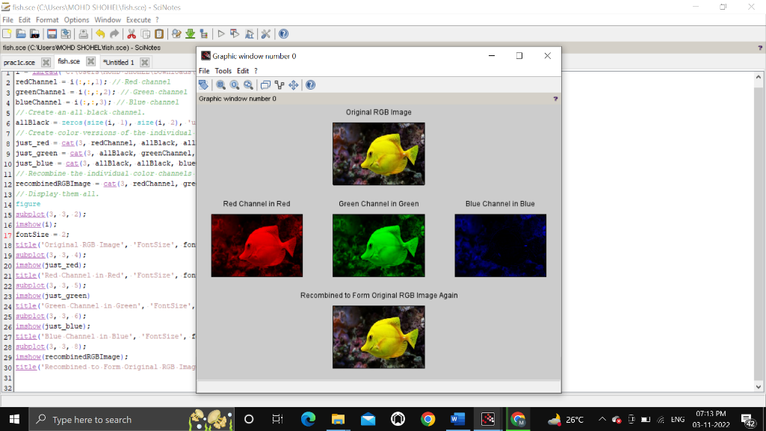

(i)

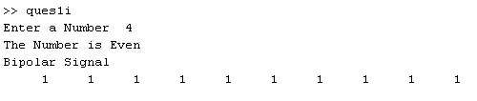

(j)

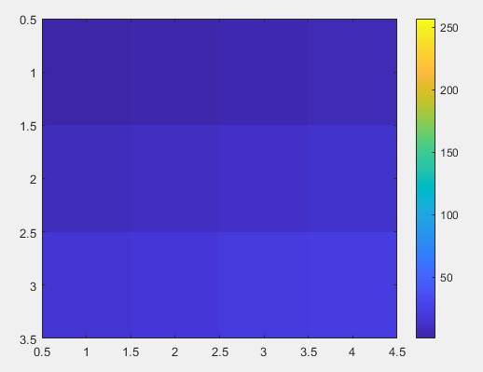

Question 2 : To write and execute image processing programs using point processing method

a. Obtain Negative image

b. Obtain Flip image

c. Thresholding

d. Contrast stretching

Solution :

Code -

% (a)

a=imread("C:\Users\MOHD SHOHEL\Downloads\fish.jpg");

figure

imshow(a);

title("Original Image")

d=255-a;

figure

imshow(d);

title("Negative Image")

% (b)

I=imread("C:\Users\MOHD SHOHEL\Downloads\fish.jpg");

S2 = imrotate(I,180);

imshow(S2);

% (c)

sam_img = imread('C:\Users\MOHD SHOHEL\Downloads\fish.jpg');

subplot(1,2,1), title('Original Image'), imshow(sam_img);

subplot(1,2,2), title('Binary Image at D0 = 110'), imshow(im2bw(sam_img, 110/256));

% (d)

X=imread("C:\Users\MOHD SHOHEL\Downloads\duck.jpg");

//X = imread('image.jpg'); //%reading a grayscale image

figure(1);

imshow(X);

title('Original Image')

a = min(X(:)); // %minimum pixel of image X

b = max(X(:)); //%maximum pixel of image X

X= (X-a).*(255/(b-a)); //%just using the formula above

figure(2);

imshow(X);

title('Contrast Streached Image')

Output :

(a)

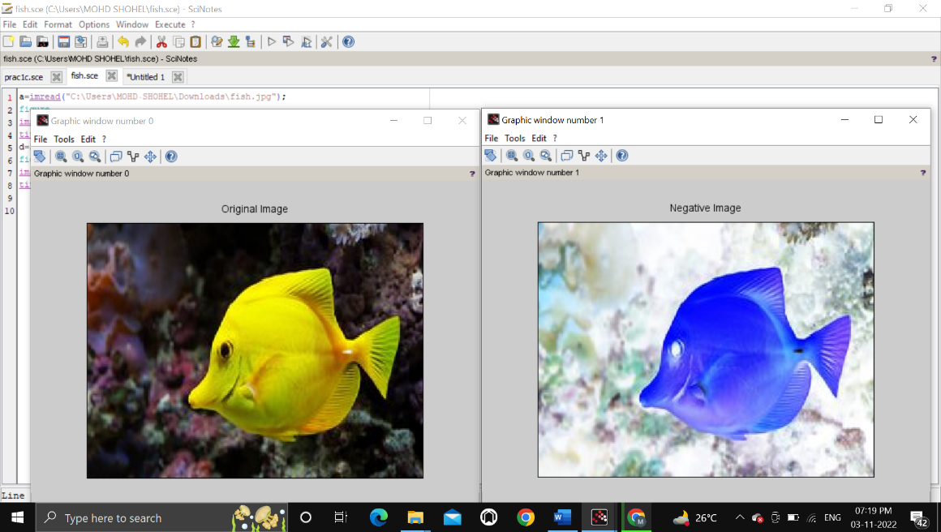

(b)

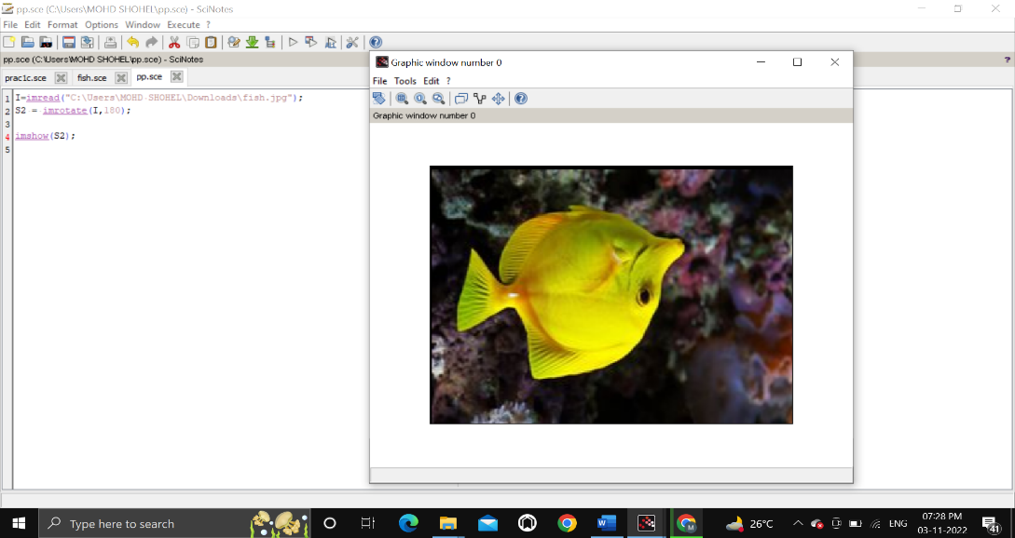

(c)

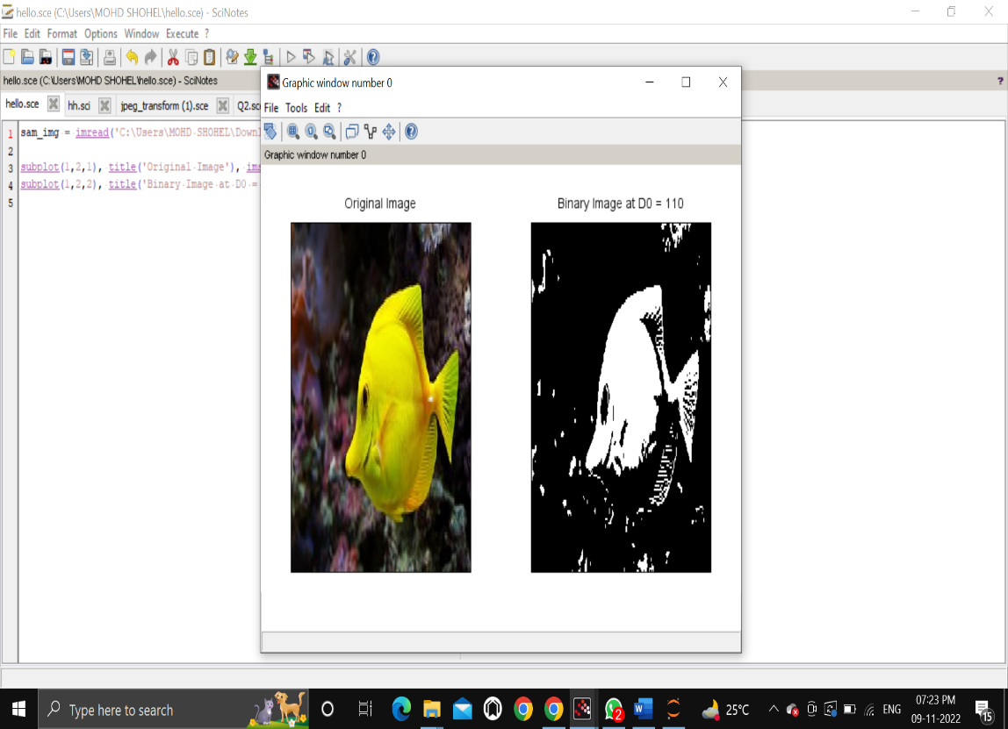

(d)

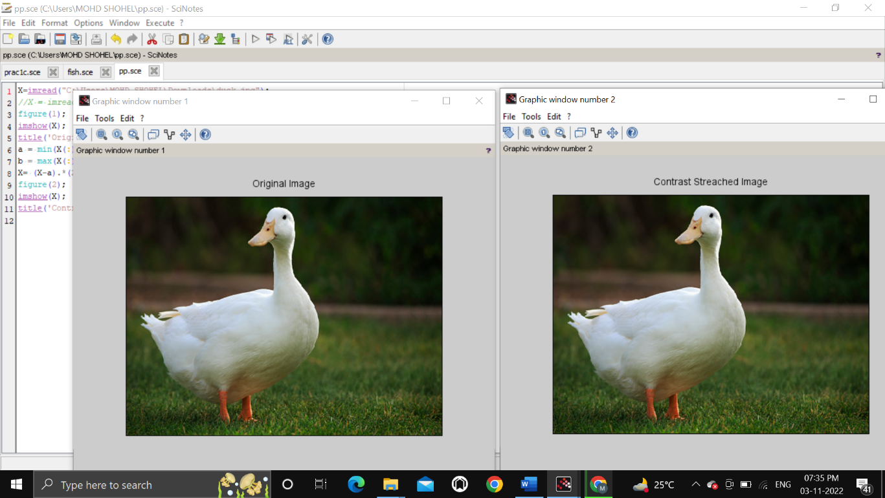

Question 3 : To write and execute programs for image arithmetic operations

a. Addition of two images

b. Subtract one image from other image

c. Calculate mean value of image

Solution :

Code -

% (a)

% Read two grayscale uint8 images into the workspace.

im1=imread("C:\Users\MOHD SHOHEL\Downloads\nature1.jpg");

im2=imread("C:\Users\MOHD SHOHEL\Downloads\nature2.jpg");

//im1 = imread('Test_images/lena_1.jpeg');

//im2 = imresize(imread('Test_images/coloredChips.png'), [225,225]);

subplot(1,2,1), title('Image 1'), imshow(im1);

subplot(1,2,2), title('Image 2'), imshow(im2);

im3 = imadd(im1, im2);

imshow(im3);

% (b)

im4 = im1 - im2;

im5 = im2 - im1;

subplot(1,3,1), title('Image 3 = Image 1 + Image 2'), imshow(im3);

subplot(1,3,2), title('Image 4 = Image 1 - Image 2'), imshow(im4);

subplot(1,3,3), title('Image 5 = Image 2 - Image 1'), imshow(im5);

% (c)

printf('Mean of the image 1 : %.3f\n',mean(im2double(im1)));

printf('Mean of the image 2 : %.3f',mean(im2double(im2)));

Output :

(a)

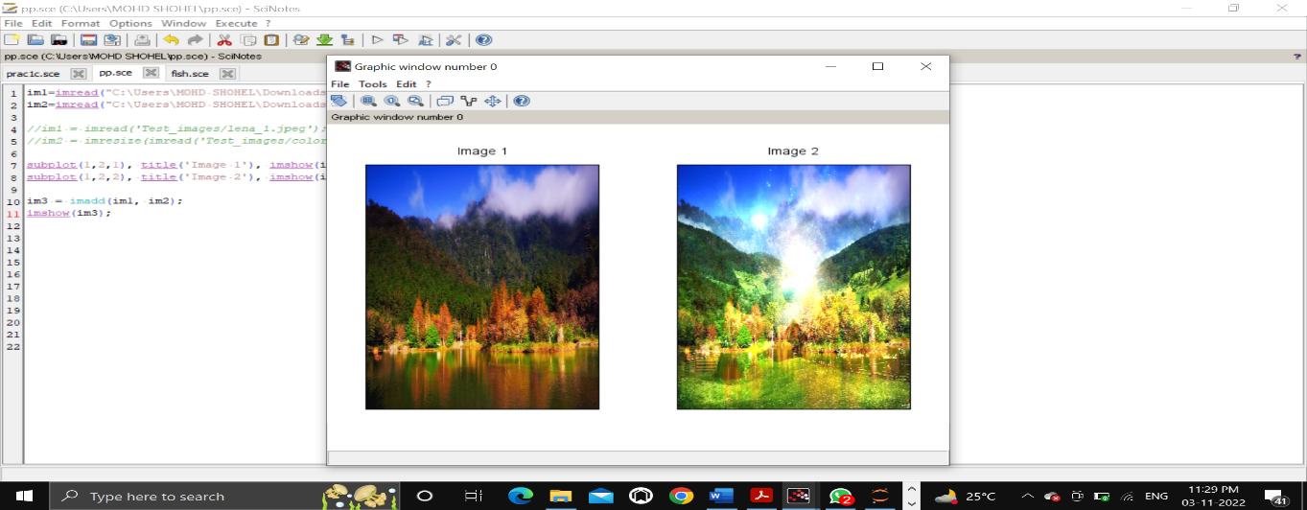

(b)

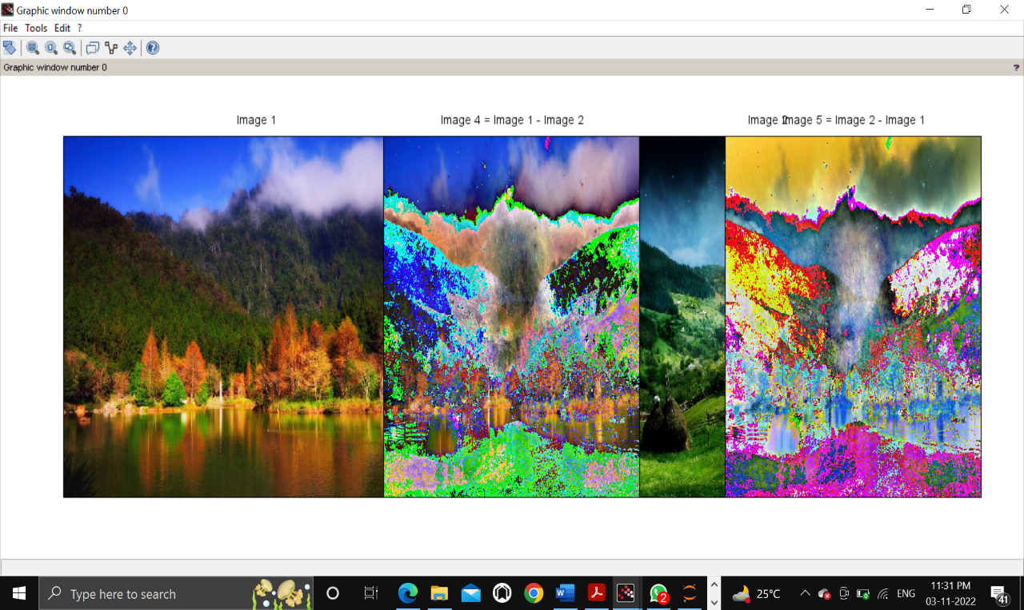

(c)

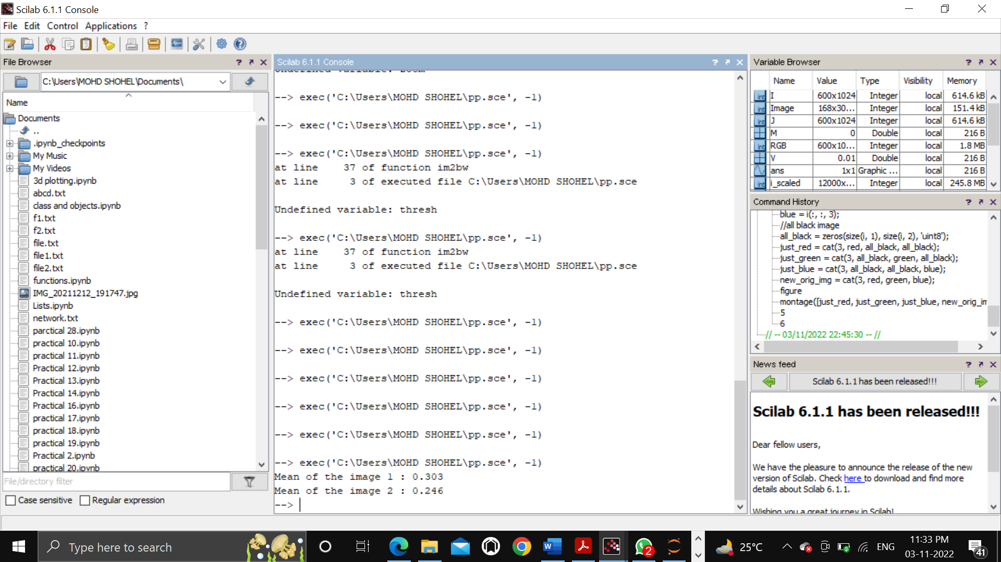

Question 4 : To write and execute programs for image logical operations

a. AND operation between two images

b. OR operation between two images

c. Calculate intersection of two images

d. NOT operation (Negative image)

Solution :

Code -

% (a)

i= imread('C:\Users\MOHD SHOHEL\Downloads\f1.jfif');

j= imread('C:\Users\MOHD SHOHEL\Downloads\f2.jfif');

andimage=imabsdiff(i,j);

imshow(andimage);

% (b)

i= imread('C:\Users\MOHD SHOHEL\Downloads\f1.jfif');

j= imread('C:\Users\MOHD SHOHEL\Downloads\f2.jfif');

orimage=bitor(i,j);

imshow(orimage);

% (c)

a= imread('C:\Users\MOHD SHOHEL\Downloads\f1.jfif');

b=imread('C:\Users\MOHD SHOHEL\Downloads\f2.jfif');

intersectedImage=bitand(a,b);

subplot(2,2,3), imshow(a), title('rice');

subplot(2,2,4), imshow(b), title('smile');

subplot(2,2,2), imshow(intersectedImage), title('Intersection');

% (d)

W= imread('C:\Users\MOHD SHOHEL\Downloads\f1.jfif');

NotW= bitcmp(W);

figure

subplot(1,2,1)

imshow(W)

title("cat")

subplot(1,2,2)

imshow(NotW)

title("NOT Operation")

Output :

(a)

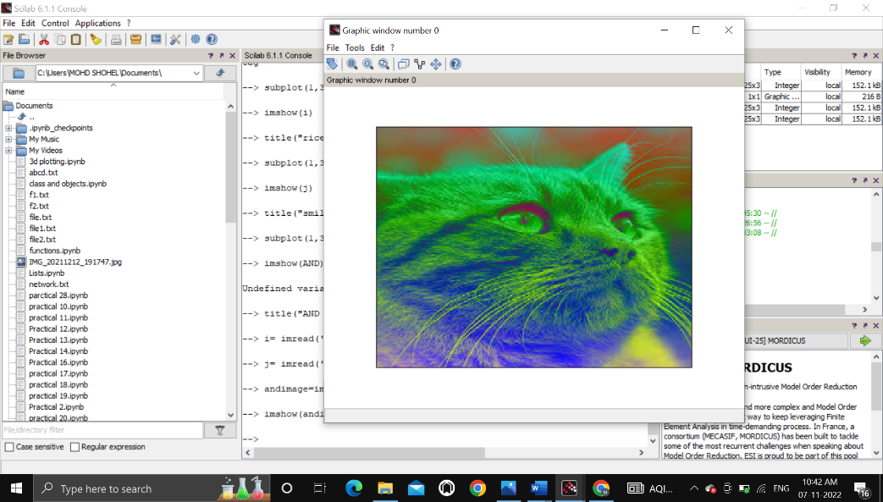

(b)

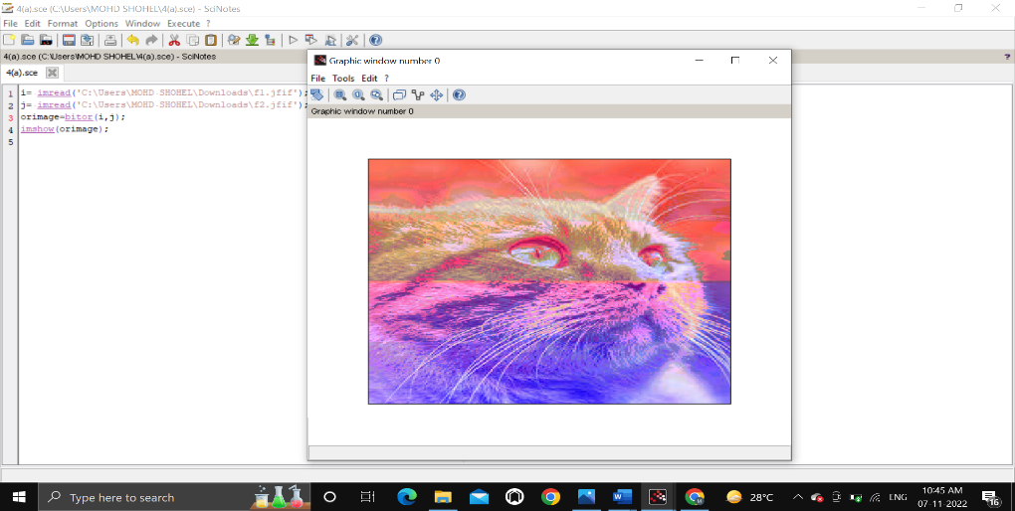

(c)

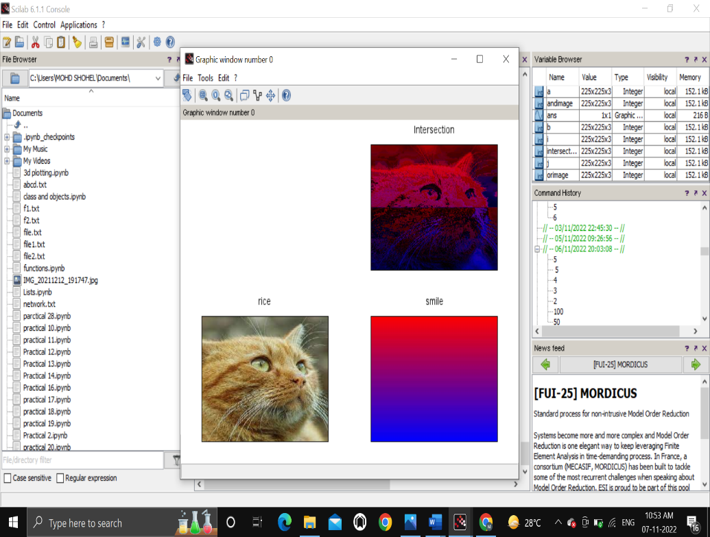

(d)

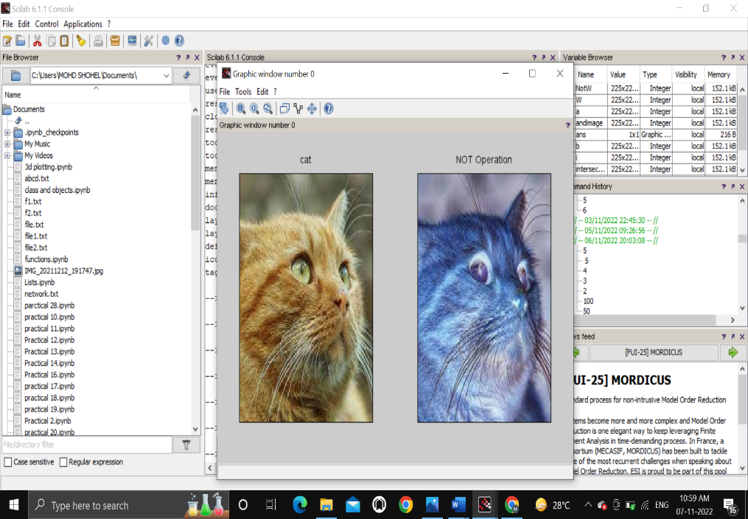

Question 5 : To write a program for histogram calculation and equalization using

a. Standard MATLAB function

b. Program without using standard MATLAB functions

Solution :

Code -

% (a)

I= rgb2gray(imread("C:\Users\MOHD SHOHEL\Downloads\fish.jpg"));

subplot(2,2,1);

imshow(I);

subplot(2,2,2);

imhist(I,[],1);

J=imhistequal(I);

subplot(2,2,3);

imshow(J);

subplot(2,2,4);

imhist(J,[], 1);

% (b)

GIm=imread('penguin.jpg');

numofpixels=size(GIm,1)*size(GIm,2);

figure

imshow(GIm);

title('Original Image');

HIm=uint8(zeros(size(GIm,1),size(GIm,2)));

freq=zeros(256,1);

probf=zeros(256,1);

probc=zeros(256,1);

cum=zeros(256,1);

output=zeros(256,1);

%freq counts the occurrence of each pixel value.

%The probability of each occurrence is calculated by probf.

for i=1:size(GIm,1)

for j=1:size(GIm,2)

value=GIm(i,j);

freq(value+1)=freq(value+1)+1;

probf(value+1)=freq(value+1)/numofpixels;

end

end

sum=0;

no_bins=255;

%The cumulative distribution probability is calculated.

for i=1:size(probf)

sum=sum+freq(i);

cum(i)=sum;

probc(i)=cum(i)/numofpixels;

output(i)=round(probc(i)*no_bins);

end

for i=1:size(GIm,1)

for j=1:size(GIm,2)

HIm(i,j)=output(GIm(i,j)+1);

end

end

figure,imshow(HIm);

title('Histogram equalization');

Output :

(a)

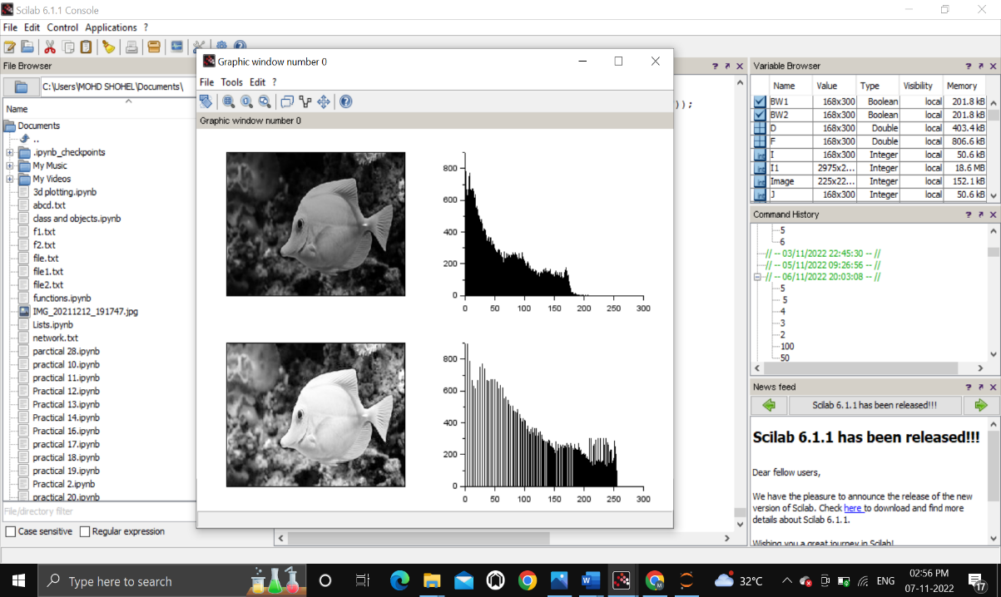

(b)

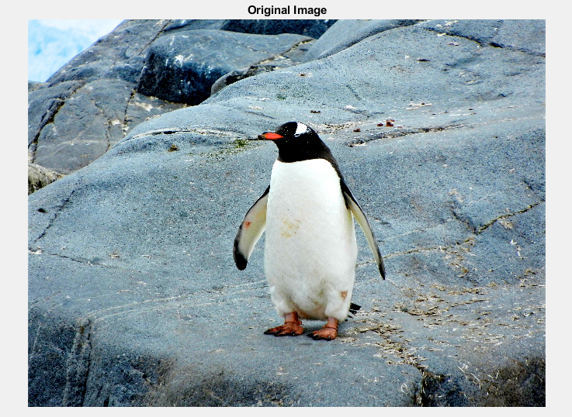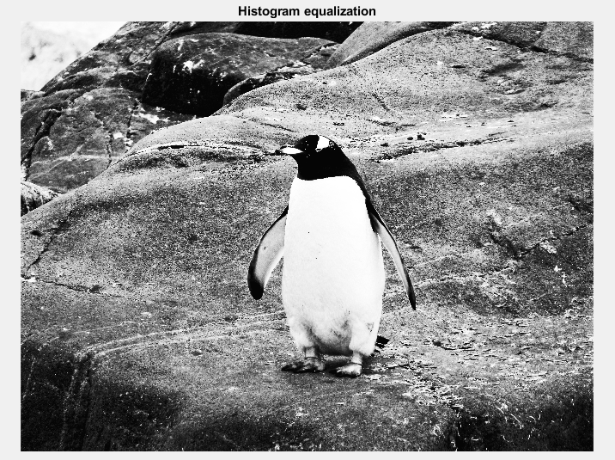

Question 6 : To write and execute program for geometric transformation of image

a. Translation

b. Scaling

c. Rotation

d. Shrinking

e. Zooming

Solution :

Code -

% (a)

S1=imread("C:\Users\MOHD SHOHEL\Downloads\fish.jpg");

mat = [ 1 0 0;...

0 1 0;...

20 0 1];

S2 = imtransform(S1,mat,'affine');

mat = [ 1 0 0;...

0 1 0;...

0 -20 1];

S3 = imtransform(S1,mat,'affine');

mat = [ 1 0 0;...

0 1 0;...

-20 30 1];

S4 = imtransform(S1,mat,'affine');

subplot(2,2,1), title('Original Image'), imshow(S1);

subplot(2,2,2), title('Translation for x = 20'), imshow(S2);

subplot(2,2,3), title('Translation for y = -20'), imshow(S3);

subplot(2,2,4), title('Translation for (-20,30)'), imshow(S4);

% (b)

s_img=imread("C:\Users\MOHD SHOHEL\Downloads\fish.jpg");

width = size(s_img, 'c');

height = size(s_img, 'r');

w = 2;

h = 1;

mat = [ w 0;

0 h;

0 0];

sc1 = imtransform(s_img, mat, 'affine', width*w, height*h);

w = 1;

h = 2;

mat = [ w 0;

0 h;

0 0];

sc2 = imtransform(s_img, mat, 'affine', width*w, height*h);

w = 2;

h = 2;

mat = [ w 0;

0 h;

0 0];

sc3 = imtransform(s_img, mat, 'affine', width*w, height*h);

function s = str(img)

s = 'Size : ' + strcat(string(size(img)), ' * ');

endfunction;

subplot(3,3,1), title('Original Image'), xlabel(str(s_img)), imshow(s_img);

subplot(3,2,2), title('Image scaling width by 2'),xlabel(str(sc1)), imshow(sc1);

subplot(2,3,4), title('Image scaling height by 2'),xlabel(str(sc2)), imshow(sc2);

subplot(2,2,4), title('Image scaling by 2'),xlabel(str(sc3)), imshow(sc3);

% (c)

subplot(2,2,1), title('Original Image'), imshow(s_img);

subplot(2,2,2), title('Image rotation by 45'), imshow(imrotate(s_img, 45));

subplot(2,2,3), title('Image rotaion by -45'), imshow(imrotate(s_img, -45));

subplot(2,2,4), title('Image rotaion by 180'), imshow(imrotate(s_img, 180));

% (d)

[r c] = size(s_img);

f = 0.5;

im_50 = zeros(r, c, 'uint8');

shrinked = rgb2gray(imresize(s_img, f));

im_50(48:143, 40:120) = shrinked;

subplot(121), title('Original Image'), imshow(rgb2gray(s_img));

subplot(122), title('Image Shrinked by 50%'), imshow(im_50);

% (e)

f = 2;

im2 = imresize(s_img, f);

subplot(121), title('Original Image'), imshow(s_img);

subplot(122), title('Image zoomed by 200%'), imshow(im2(96:287, 81:241, :));

Output :

(a)

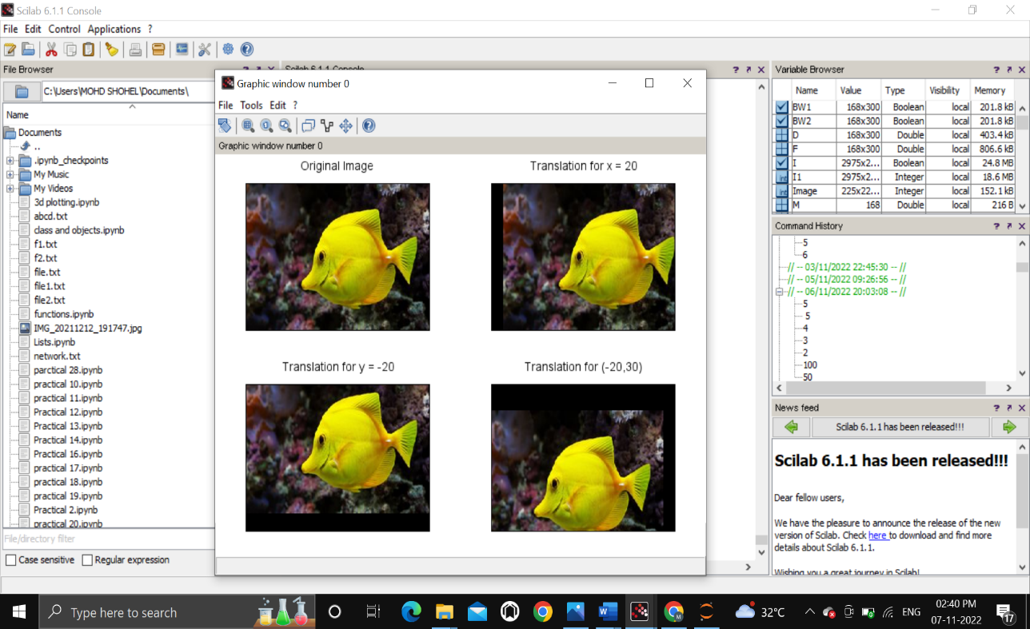

(b)

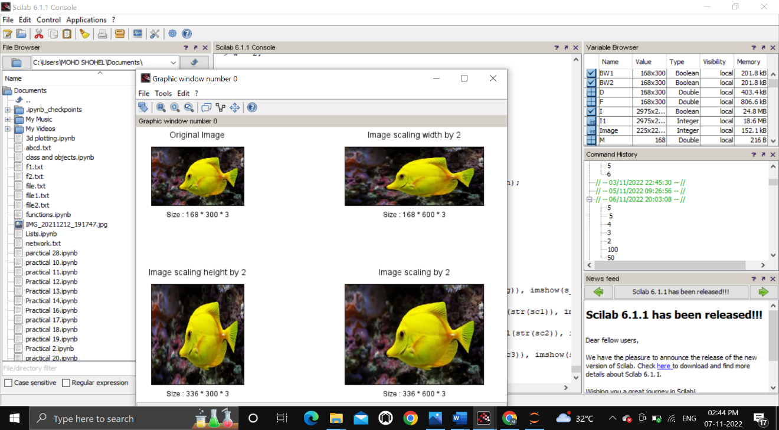

(c)

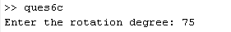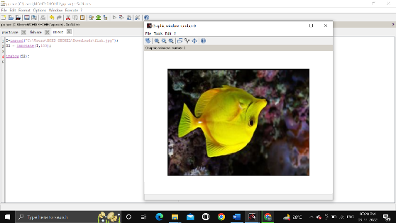

(d)

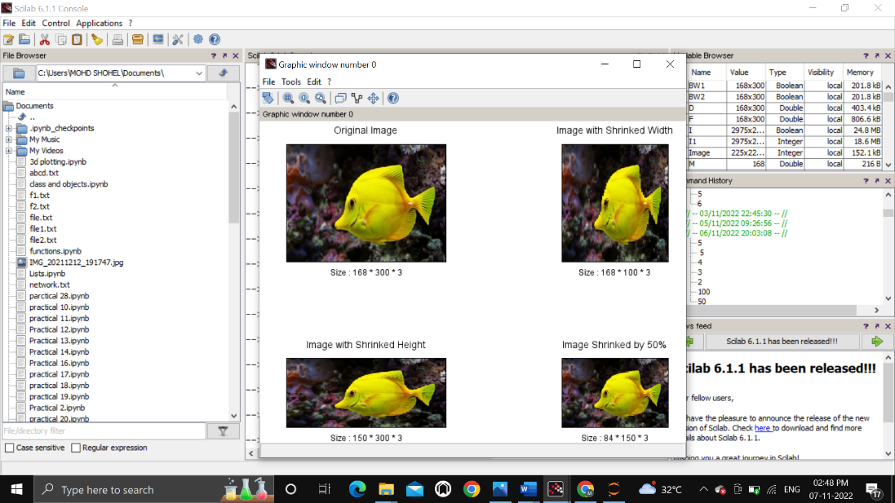

(e)

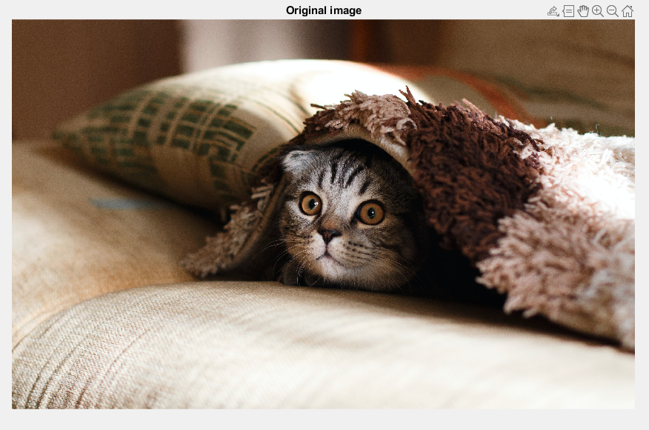

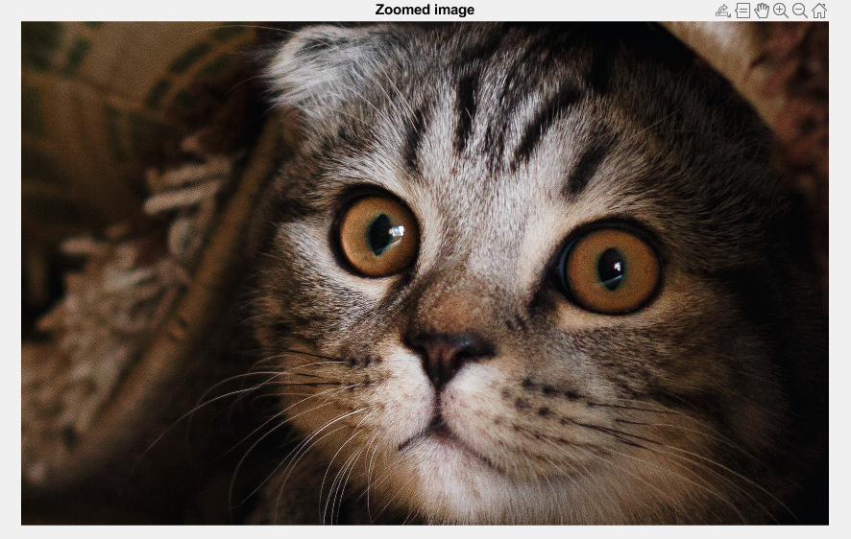

Question 7 : To understand various image noise models and to write programs for

a. image restoration

b. Remove Salt and Pepper Noise

c. Minimize Gaussian noise

d. Median filter

Solution :

Code -

% (a)

im1 = imread('C:\Users\MOHD SHOHEL\Downloads\fish.jpg');

f = fspecial('gaussian', [8, 8], 2);

subplot(121), title('Noisy Image'), imshow(im1);

subplot(122), title('Filtered Image'), imshow(imfilter(im1, f));

% (b)

im2 = rgb2gray(imread('C:\Users\MOHD SHOHEL\Downloads\fish.jpg'));

im3 = imnoise(im2, 'salt & pepper', 0.3);

subplot(131), title('Original Image'), imshow(im2);

subplot(132), title('Salt & Pepper Noised Image'), imshow(im3);

subplot(133), title('Filtered Image'), imshow(immedian(im2,3));

% (c)

im1 = imread('C:\Users\MOHD SHOHEL\Downloads\fish.jpg');

im2 = imnoise(im1, 'gaussian');

f = fspecial('average', 3);

subplot(131), title('Original Image'), imshow(im1);

subplot(132), title('Gaussian Noised Image'), imshow(im2);

subplot(133), title('Filtered Image'), imshow(imfilter(im1, f));

% (d)

RGB=imread("C:\Users\MOHD SHOHEL\Downloads\nature1.jpg");

I = rgb2gray(RGB);

imshow(I);

title('Original GrayScale Image');

J = imnoise(I,'gaussian',0,0.025);

figure();

imshow(J);

title('Portion of the Image with Added Gaussian Noise');

K = wiener2(J,[5 5]);

figure();

imshow(K);

title('Portion of the Image with Noise Removed by Wiener Filter');

Output:

(a)

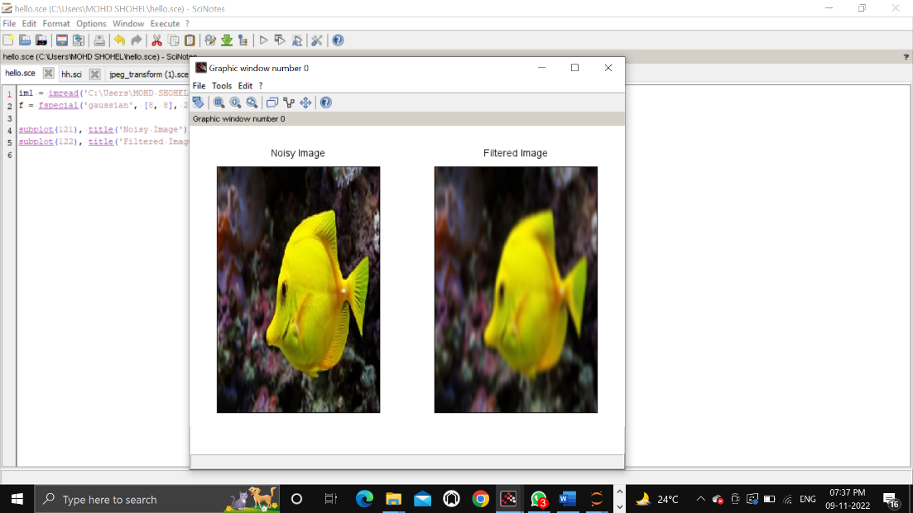

(b)

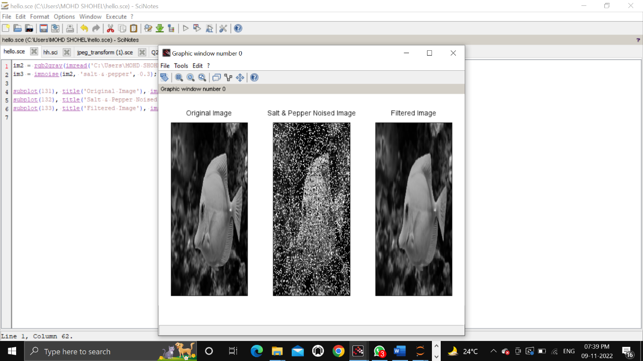

(c)

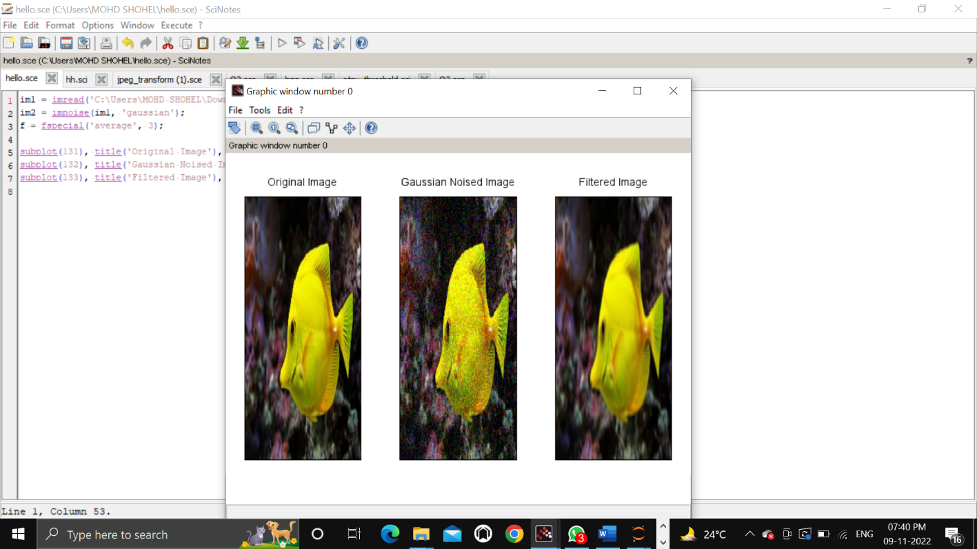

(d)

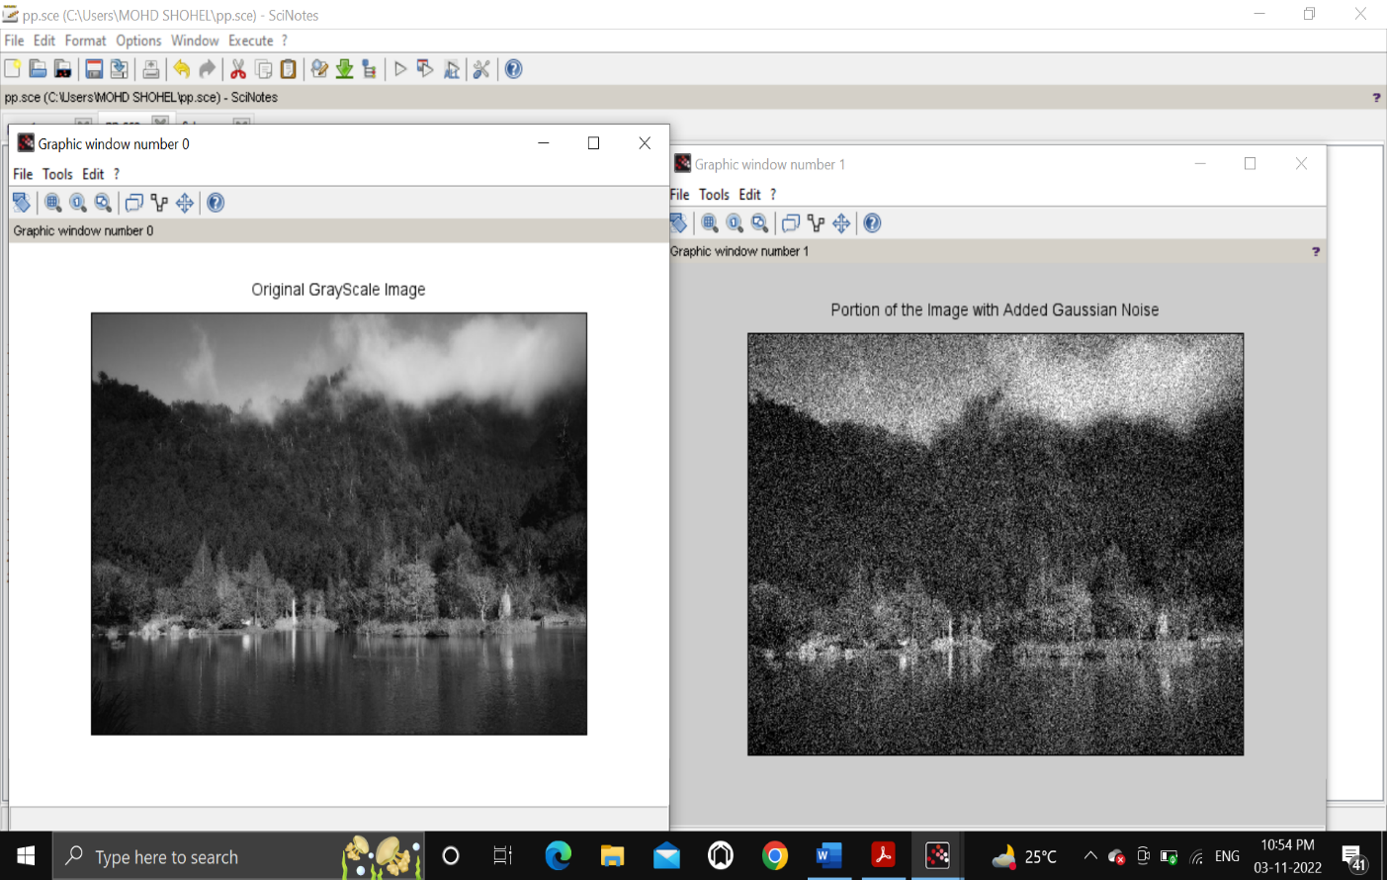

Question 8: Write and execute programs to use spatial low pass and high pass filters.

Solution :

Code -

//High pass

i1= imread('C:\Users\MOHD SHOHEL\Downloads\fish.jpg');

g_filter = fspecial('gaussian');

i2 = imfilter(i1, g_filter);

g_filter2 = fspecial('gaussian', [8,8], 10);

i3 = imfilter(i1, g_filter2);

g_filter3 = fspecial('gaussian',[25,25], 31);

i4 = imfilter(i1, g_filter3);

subplot(2,2,1), title('Original Image'), imshow(i1);

subplot(2,2,2), title('Default Gaussian kernel'), imshow(i2);

subplot(2,2,3), title('Gaussian kernel with 8 * 8 with sigma = 10'), imshow(i3);

subplot(2,2,4), title('Gaussian kernel with 25 * 25 with sigma = 31'), imshow(i4);

//low pass

i1=imread("C:\Users\MOHD SHOHEL\Downloads\fish.jpg");

l_filter = fspecial('laplacian');

i2 = imfilter(i1, l_filter);

subplot(1,2,1), title('Original Image'), imshow(i1);

subplot(1,2,2), title('Laplacian Filter'), imshow(i2);

Output:

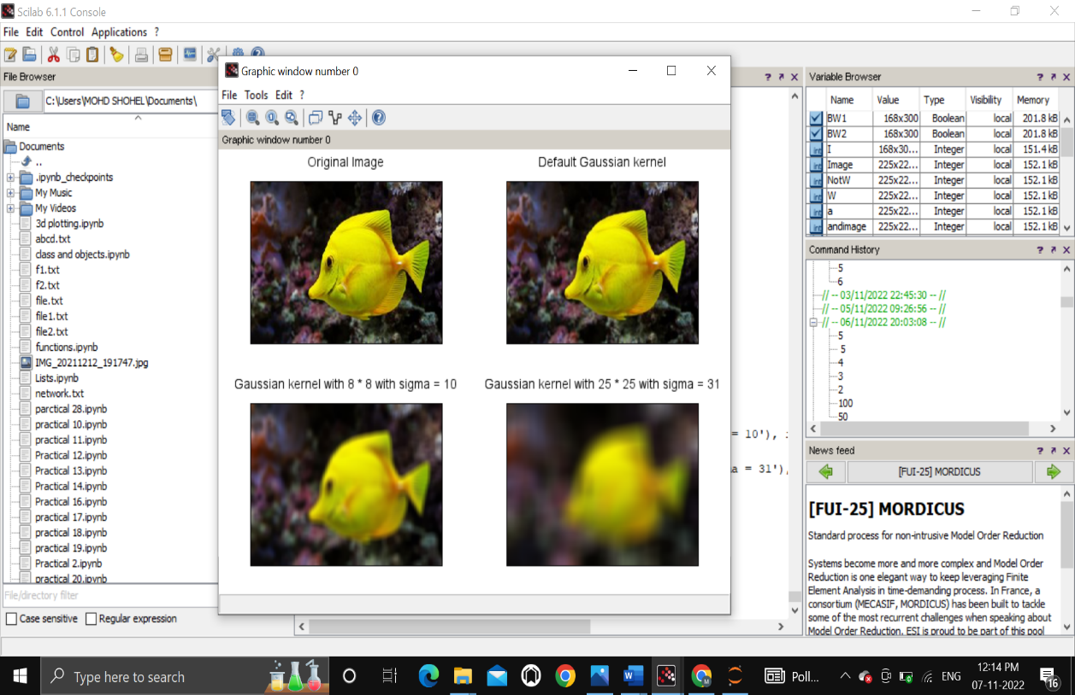

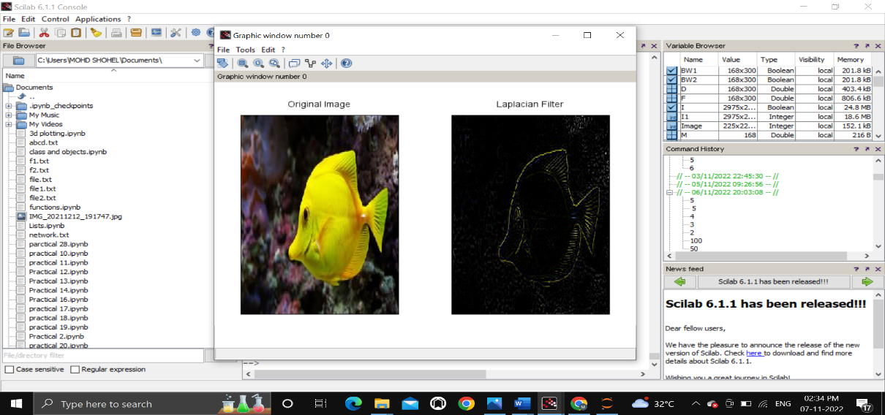

Question 9: Write and execute programs for image frequency domain filtering

a. Apply FFT on given image

b. Perform low pass and high pass filtering in frequency domain

c. Apply IFFT to reconstruct image

Solution :

Code -

% (a)

img = rgb2gray(imread('C:\Users\MOHD SHOHEL\Downloads\fish.jpg'));

ft_img = fft(double(img));

subplot(1,2,1), title('Original Image'), imshow(img);

subplot(1,2,2), title('Direct Fourier Transformed Image'),imshow(ft_img);

% (b)

// Butterworth Filters

G11 = mkfftfilter(img, 'butterworth1', 0.3);

H11 = 1 - G11;

subplot(121), title('DFT Butterworth Low Pass Image'), imshow(G11);

subplot(122), title('DFT Butterworth High Pass Image'),imshow(H11);

(c)

S2 = ft_img .* fftshift(G11);

bwh_l = uint8(ifft(S2));

S2 = ft_img .* fftshift(H11);

bwh_h = uint8(ifft(S2));

subplot(121), title('DFT Butterworth Low Pass Image'), imshow(bwh_l);

subplot(122), title('DFT Butterworth High Pass Image'),imshow(bwh_h);

Output:

(a)

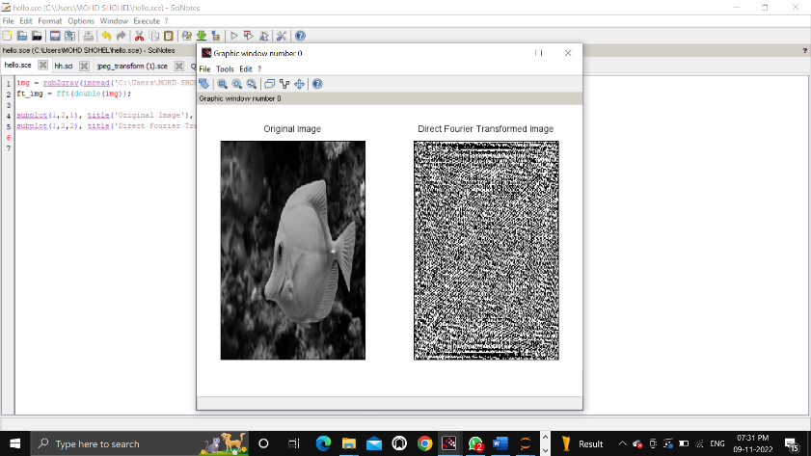

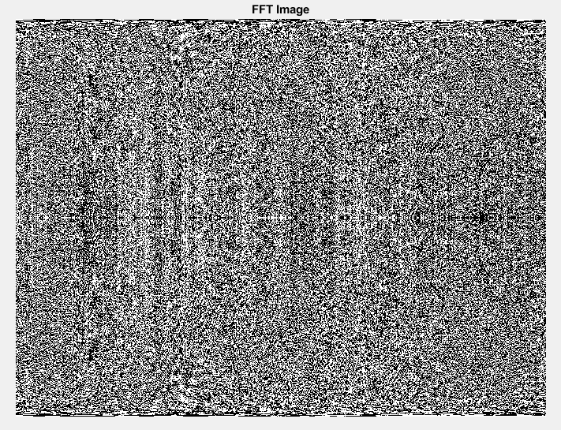

(b)

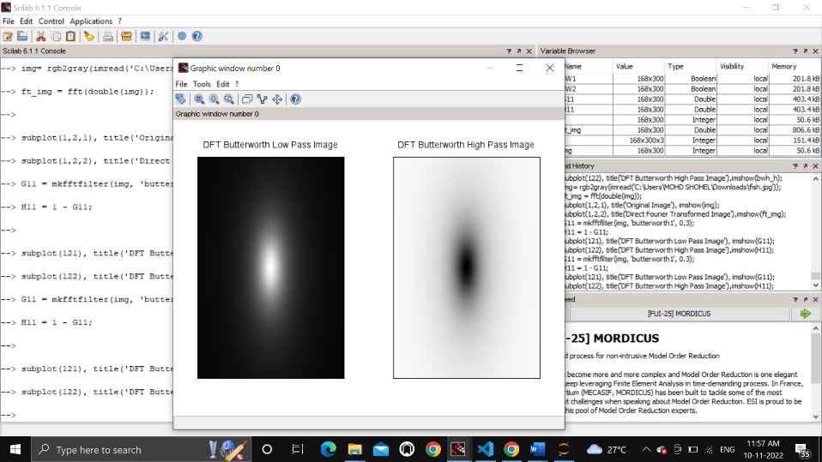

(c)

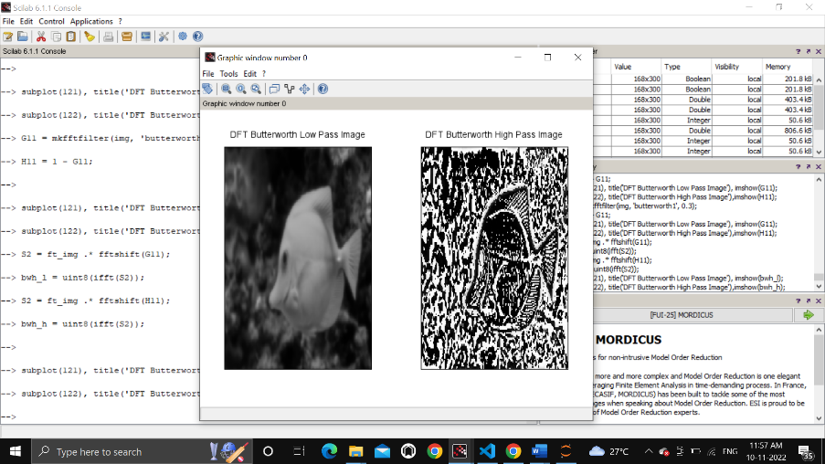

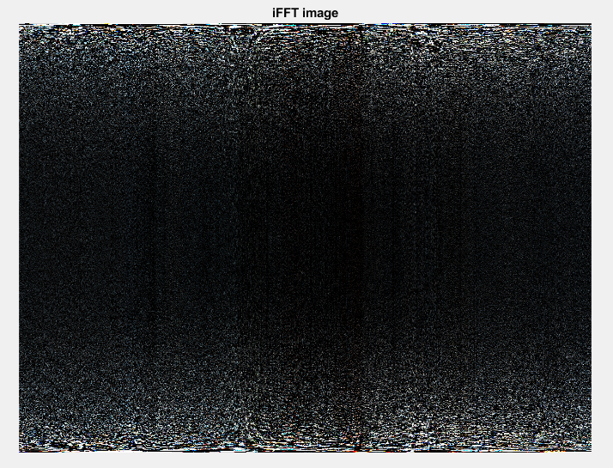

Question 10: Write a program in C and MATLAB/SCILAB for edge detection using different edge

detection mask.

Solution :

Code -

i= imread('C:\Users\MOHD SHOHEL\Downloads\fish.jpg');

I=rgb2gray(i);

BW1=edge(I,"prewitt");

BW2=edge(I,"sobel");

BW3=edge(I,"roberts");

subplot(2,2,1);

imshow(I);

title("original");

subplot(2,2,2);

imshow(BW1);

title("Prewitt");

subplot(2,2,3);

imshow(BW2);

title("Sobel");

subplot(2,2,4);

imshow(BW3);

title("Roberts");

Output:

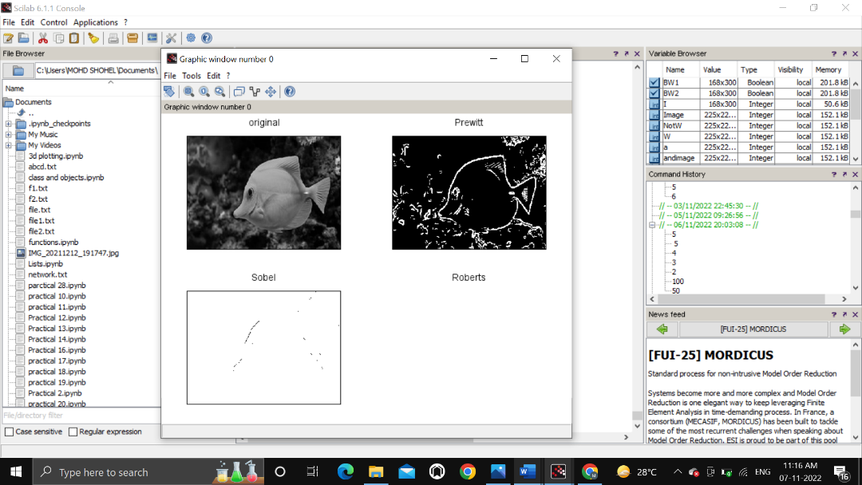

Question 11: Write and execute a program for image morphological operations erosion and dilation.

Solution :

Code -

I1= imread('C:\Users\MOHD SHOHEL\Downloads\grey.jpg');

I=im2bw(I1,0.5);

se=imcreatese('cross',3,3);

subplot(2, 3, 1);

imshow(I);

title("Original image");

dilate = imdilate(I, se);

subplot(2, 3, 2);

imshow(dilate);

title("Dilated image");

erode = imerode(I, se);

subplot(2, 3, 3);

imshow(erode);

title("Eroded image");

Output:

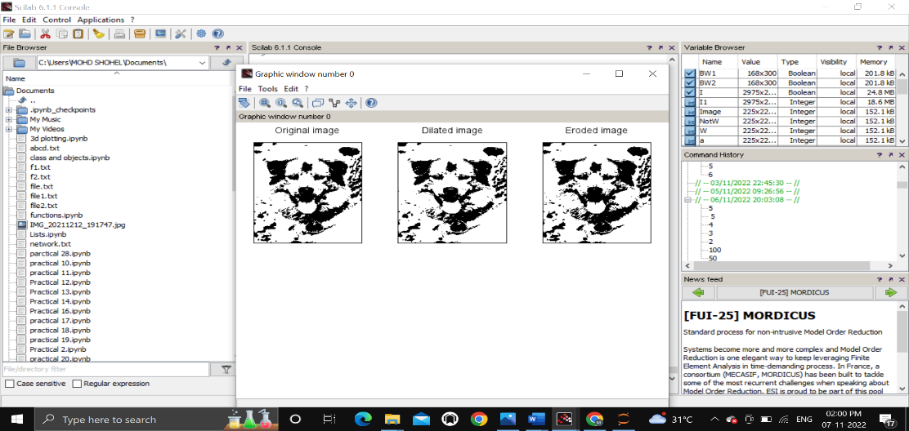

**Thank You**